HANDS-ON 4 :Template-Driven Forms & Validation
Project Structure:
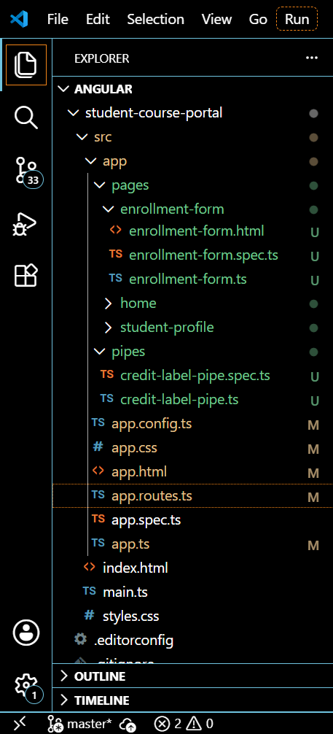
Enrolment-form.html
<h2>Student Enrollment Request</h2>

<!-- #enrollForm='ngForm' gives access to the NgForm directive instance -->
<form #enrollForm="ngForm" (ngSubmit)="onSubmit(enrollForm)">

<!-- Student Name -->
<div class="form-group">
<label for="studentName">Student Name</label>
<input
type="text"
id="studentName"
name="studentName"
[(ngModel)]="studentName"
#nameCtrl="ngModel"
required
minlength="3">

<!-- Step 44: contextual error messages, shown only after field is touched -->
<span *ngIf="nameCtrl.touched && nameCtrl.errors?.['required']" class="error">
Name is required
</span>
<span *ngIf="nameCtrl.touched && nameCtrl.errors?.['minlength']" class="error">
Name must be at least 3 characters
</span>
</div>

<!-- Student Email -->
<div class="form-group">
<label for="studentEmail">Student Email</label>
<input
type="email"
id="studentEmail"
name="studentEmail"
[(ngModel)]="studentEmail"
#emailCtrl="ngModel"
required
email>

<span *ngIf="emailCtrl.touched && emailCtrl.errors?.['required']" class="error">
Email is required
</span>
<span *ngIf="emailCtrl.touched && emailCtrl.errors?.['email']" class="error">
Enter a valid email address
</span>
</div>

<!-- Course ID -->
<div class="form-group">
<label for="courseId">Course ID</label>
<input
type="number"
id="courseId"
name="courseId"
[(ngModel)]="courseId"
#courseCtrl="ngModel"
required>

<span *ngIf="courseCtrl.touched && courseCtrl.errors?.['required']" class="error">
Course ID is required
</span>
</div>

<!-- Preferred Semester -->
<div class="form-group">
<label for="preferredSemester">Preferred Semester</label>
<select
id="preferredSemester"
name="preferredSemester"
[(ngModel)]="preferredSemester"
required>
<option value="" disabled>Select semester</option>
<option value="Odd">Odd</option>
<option value="Even">Even</option>
</select>
</div>

<!-- Agree to Terms -->
<div class="form-group checkbox-group">
<label>
<input
type="checkbox"
name="agreeToTerms"
[(ngModel)]="agreeToTerms"
required>
I agree to the terms and conditions
</label>
</div>

<!-- Step 41: disabled while form is invalid -->
<button type="submit" [disabled]="enrollForm.invalid">Submit</button>

<!-- Step 47: reset button -->
<button type="button" (click)="resetForm(enrollForm)">Reset</button>

<!-- Step 46: success message -->
<div *ngIf="submitted" class="success-message">
Enrollment request submitted successfully!
</div>

</form>
Enrolment-form.ts
import { Component } from '@angular/core';
import { CommonModule } from '@angular/common';
import { FormsModule, NgForm } from '@angular/forms'; // FormsModule enables ngModel & ngForm

@Component({
selector: 'app-enrollment-form',
imports: [CommonModule, FormsModule], // CommonModule for *ngIf, FormsModule for template-driven forms
templateUrl: './enrollment-form.html',
styleUrl: './enrollment-form.css'
})
export class EnrollmentForm {

// Model properties bound via [(ngModel)] in the template
studentName: string = '';
studentEmail: string = '';
courseId: number | null = null;
preferredSemester: string = '';
agreeToTerms: boolean = false;

// Toggled true after successful submission (Step 46)
submitted: boolean = false;

// Step 40: called on (ngSubmit), receives the NgForm reference
onSubmit(form: NgForm): void {
console.log('Form Value:', form.value); // logs form.value
console.log('Form Valid:', form.valid); // logs form.valid

if (form.valid) {
this.submitted = true; // shows success message (Step 46)
}
}

// Step 47: resets all fields and validation states
resetForm(form: NgForm): void {
form.resetForm();
this.submitted = false;
}
}
App.routes.ts
import { Routes } from '@angular/router';
import { Home } from './pages/home/home';
import { CourseList } from './pages/course-list/course-list';
import { EnrollmentForm } from './pages/enrollment-form/enrollment-form'; // new import for Hands-On 4

export const routes: Routes = [
{ path: '', component: Home },
{ path: 'courses', component: CourseList },
{ path: 'enroll', component: EnrollmentForm } // Task 1, Step 38
];
OUTPUT:
